# **Mocking An API**

Hello! folks its awesome to have you here working towards understanding how to mock an api in AWS API gateway. So, let’s get started with a simple tutorial.

**Objective**: Create a Rest API and Mock the response.

Login into the AWS and open API Gateway, then create a Rest API and if you are new user start by creating a new API and follow it up by giving the details. You’d have a similar screen

Then Choose **CREATE API**.

Now you’ll be shown up to create a resource for your API, Choose Create Resource under the **Actions** tab and create a new resource

After creating your resource, you will find it populated like this

Now select your resource and under the Actions tab create a new **Method** and select **GET,** then under the **integration type** select **Mock** **Integration**.

Click **SAVE.** By doing so now you’ll have a screen which portrays the basic structure of a Rest API.

Now click **Integration Response** and maximise the information which is populated.

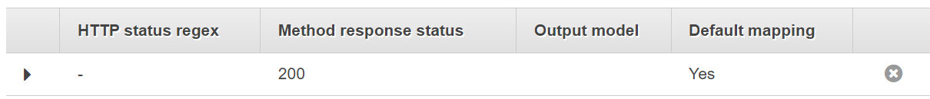

You will find **Mapping Templates** open it and under Content-Type add a new mapping template and give **application/json**

Now add the message and **SAVE.** You’d have a similar screen

After **Saving** the template go on top and **save** here as well

Now go back to the previous screen and select TEST

Now choose test and you’ll find your mock response getting populated. Now under **Actions** choose to **Deploy API** and give the following details and finally Deploy.

You will then see an invoke URL use that and open postman if you have or else open your browser and put the url and append your resource and invoke it.



**Postman Testing**

**Browser Testing**



Awesome !! now you have understood how to mock an API, feel free to research other options in mocking and **Happy Learning.**